Sample Leaflet

What is a Play Street?
A Play Street is a road that has been temporarily closed to through traffic to create space for children to play out on their doorsteps. Streets are now doing this all over the UK and it’s having really positive benefits for children and communities.
How does it happen?
Local people discuss the idea first and then apply to the council for permission to close their road for between 1-3 hours.
Some streets apply to do a one-off session. Others do it more regularly.
On the day, the road is closed to through traffic and signs and cones at the end of the street remind drivers of what’s happening. Residents can still drive in and out at walking speed.
Parents and carers are responsible for their children as on any other day.
Street play…
- Gives children the space and freedom they need to be healthy and happy
- Helps them gain skills, independence and responsibility
- Helps everyone make friends on the street
- Makes use of the space outside our front doors

“It’s so rewarding to watch my son play tag, scoot and do chalking with other kids on our street. He’s getting a good run-around and feels like he really belongs.”

“I love how Play Streets has brought our street together as a friendly, happy place to live!”

You can find out more about Play Streets in Bradford by visiting www.bradford.gov.uk/playstreets and find lots more ideas, inspiration and information on www.playingout.net

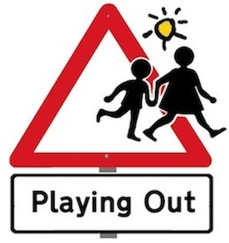
© Playing Out CIC 2010

