We want to know what you think about our plans to change the amount you pay towards the cost of your Adult Social Care Community Services.

These services include:

* Day care
* Personal care
* Outreach support
* Supported living services
* Sitting services
* Extra care housing

You can find out more about our plans at [https://www.bradford.gov.](https://www.bradford.gov.uk/adult-social-care/paying-for-support/community-care-charging-consultation/) [uk/adult-social-care/paying-for-](https://www.bradford.gov.uk/adult-social-care/paying-for-support/community-care-charging-consultation/) [support/community-care-charging-](https://www.bradford.gov.uk/adult-social-care/paying-for-support/community-care-charging-consultation/) [consultation/](https://www.bradford.gov.uk/adult-social-care/paying-for-support/community-care-charging-consultation/)

If you need any support, or if you would like this easy read information in another way like BSL or audio, please contact us by:

Phone: 01274 436464

Email: CPCharging.Consultation@ bradford.gov.uk

You can use extra paper if you need to tell us more.

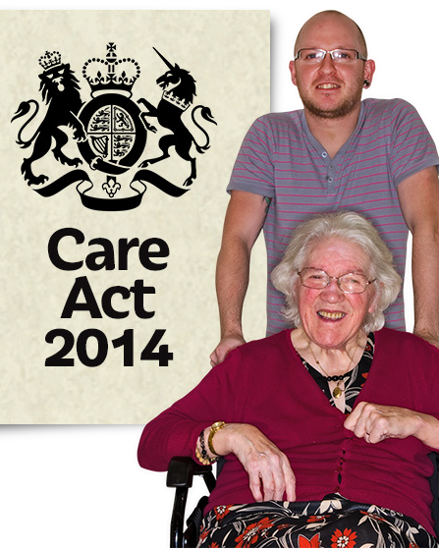The Care Act 2014 is a law. It sets out rules and regulations for Adult Social Care services.

The Care Act says that people should only pay what they can afford to pay.

Bradford Council will not make you pay more than the cost of your care.

Are you a:

User of Adult Social Care services

Unpaid Carer

Other

Are you answering on behalf of someone?

Yes

No

1. 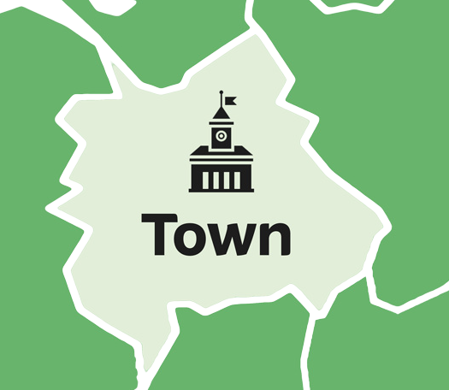What is your postcode?
2. How do you think our plans will

affect you and your family?

1. Is there anything else you would like to tell us about our plans?