Application for Temporary Traffic Regulations for a Special Event

Guidance Notes for Applicants – 2017 edition

Bradford Council actively supports and encourages special events. They are an integral part of local life and are important to local communities and economy. It is important that events take place in a safe manner and cause minimal disruption on the highway. These guidance notes are designed to help you do this.

This guidance is based on the Home Office document “The Good Practice Safety Guide” (2006) and HSE publication “The Event Safety Guide” published 1993 (HSG 195). The advice in this document is generic in nature and is offered as general advice on events affecting the highway.

Sufficient notice must be given to the highway authority to enable compliance with statutory legislation. Large events require at least 6 months notice to the Council. Small events require a minimum of 12 weeks notice to ensure no other activities take place which could affect your event being held and to allow Bradford Council to process the application. It is a good idea to submit your application once you have decided on a date and venue.

If you wish to make changes to an annual event please ensure they are agreed with the PSLG before the start of the 12 weeks notice period.

General Information – points to consider

- Who is the event aimed at? Particular groups have different risks associated with them
- How many people are expected to attend and how is that controlled i.e. tickets?
- Where will the event take place?
- Is the venue adequate for the type of event taking place?
- Is your event increasing in popularity? Do you need to review whether the venue is still suitable due to increase in numbers attending or other changes?
- Web site adverts - can the venue/road network cope with the additional people this generates?
- What will be the impact on the local community?
- Does the event or surrounding area have sufficient car parking?
- Do you need to close any part of the public highway?
- Have you considered Park and Ride to prevent on-street parking and access problems?
- Is suitable public transport available?
- When will the event take place and does it clash with any other event in the area? Note: applications for parades Monday to Friday are only approved in exceptional circumstances.

The type and size of the event will also affect the type of order required i.e. road closure order or a temporary traffic regulation order. It also affects the timescale for applications.

Event organisers need to agree who is responsible for the event; for local community events this may be an individual, for major events there may need to be a management structure for each element of the process.

The primary “duty of care” for public safety rests with the organiser (s). If the event is on any part of the highway the responsibility for public safety still rests with the organiser.

Types of events are quantified by the number of people attending

Large Events |  | Small Events
Major Events | Significant | Large Community | Small Community
5000+ | 1000 - 5000 | 500 – 1000 | Less than 500

Traffic Management Plan and Risk Assessment

A Traffic Management Plan (TM plan) must be completed and submitted with your application form; organisers must consider the traffic management and road safety implications of their event at an early stage even if they are not closing any roads. If traffic management issues have not been addressed or the event poses serious disruption and road safety concerns, then the event may not be allowed to proceed. Clearly it is important to discuss your event with the Public Safety Liaison Group (see page 6) at the earliest opportunity – usually as soon as you have a date and venue.

The TM plan needs to show how traffic will be organised both on the public highway and, if applicable, on site, and where the access and exit routes for visitors and the emergency services will be. The TM plan must not include the use of police resources to control or direct traffic or steward the event. TM is the responsibility of the event organiser. (An example TM plan for a small parade on minor roads is attached as appendix 1).

The TM plan (as part of your Event Plan) should include a full risk assessment which clearly identifies and carefully examines all risks to the travelling public, participants, employees, volunteers attending the event. The nature, location and environment of the event also need to be considered.

Your risk assessment will record all known risks giving details of how those risks are managed and reduced to an acceptable level. Further information is supplied by the Health and Safety Executive (HSE), website www.hse.gov.uk.

If your event involves using Council services for which a charge is made eg. traffic light control, signs etc the fee charged must be paid prior to the event taking place. The road closure order will not be issued if payment has not been received.

Consultation

Event organisers must consult with affected residents and businesses, and West Yorkshire Combined Authority (Metro) if a closure is on a bus route. Written confirmation that this has been carried out and any resulting comments must be forwarded to the Council. You should discuss your event with the Council before carrying out your consultation to agree the consultation area.

Insurance

Event organisers are required to have current Public Liability Insurance (min £5,000,000). A copy of the certificate showing the insurance covers all activities related to the event must be submitted within 28 days of the event.

Traffic Management Company - Accreditation

The traffic management for certain road closures will require a qualified Traffic management Company to carry out the work. You will be advised if employing a traffic management company applies to your event. A copy of the accreditation certificate from the company who will carry out this work at the event should be included in your Event Plan.

Road Closures and other restrictions

If you need to close a road(s) or any part of the public highway you will need to submit a plan showing the highway you wish to close, duration and any diversion route identified.
If your event clashes with any already planned roadworks which cannot be postponed your event may have to be rearranged. Road closure orders are normally issued 2 -3 weeks prior to the event. All fees must be paid prior to the issue of the road closure order.
You are not permitted to close any part of the public highway without lawful authority.

Planning for a Road Closure

The planning should include:

- Co-ordination with highway authority (who co-ordinate roadworks with events as required by the Traffic Management Act 2004).
- Provide information to affected residents/businesses
- Reference to Chapter 8 of the Traffic Signs Manual
- Consideration of how to keep disruption to a minimum
- Suspension of existing restrictions and/or bus stops
- Diversion route
- Parades should be held on one side of the carriageway only to allow access for emergency vehicles on blue lights.

Temporary traffic regulation Orders

Your event may require a temporary Traffic Regulation Order (TTRO); for instance to restrict on street parking to allow better access to the venue. A TTRO application must be made at least six months before the event is due to take place to allow the statutory legal process to be carried out.

A temporary Traffic Regulation Order will incur a charge; see appendix 2 for list of charges. You will be advised of costs on an individual event basis. Full payment will be necessary eight weeks prior to the event and is not refundable. The type of Order required for your event will be at the discretion of the Traffic Officer processing your application.

Parking Restrictions

If you require parking to be suspended on any road for the event you should list the exact locations on the application form or include a plan with your application. Suspension notices are arranged through the Council’s Parking Services department. Residents and businesses affected by suspension of the restrictions must be consulted and, if possible, alternative parking arranged.

Event Organisers can hire “No Waiting” cones from the highways department if required. There is a charge for hiring and for any cones not returned. Organisers with their own supply of cones must apply to Highways Dept for permission to place them on the public highway.

Cones cannot be obtained from the Police.

Signs on the highway

The Traffic Management Act 2004 requires that advance signing (see page 4) is erected along the route of any roads to be closed for an event. The signing must be erected two weeks before the event date and removed immediately after the event. Organisers are responsible for the manufacture, erecting, maintenance and removal of all signing.

Directional signs to the event

The following criteria will be used to determine whether additional direction signing is necessary; as detailed in Department for Transport Traffic Advisory leaflet no. 4/11.

- The existing signing is inadequate to guide people to the event.

- The signing should only be used to guide traffic intent on finding the event and therefore would only be erected from the nearest “A” or “B” road in question.

- Signs will not be approved if they are deemed purely advertisements in order to encourage extra visitors.

- The signs shall not normally be erected on site more than 48 hours before the event and removed not more than 24 hours after the event – (in case they clash with other event signing).

- No other signing or fly posting is permitted for the event (Highways Act 1980 s. 132 makes fly posting illegal); failure to comply with this may result in the removal of all the signs and/or prosecution.

Regulation Road Closure signing and Diversion signing - 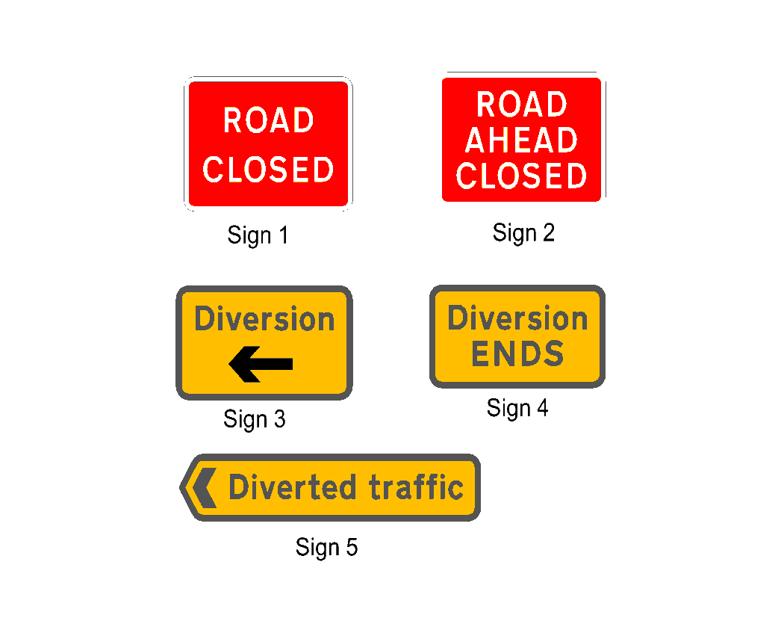

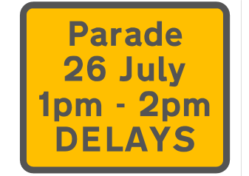

Sign 6
Example text only

Sign 1 – One sign to be placed at each end of closed section of road and at junctions within the closure. Wider roads may also require red and white traffic cones. A Steward in attendance is also required to prevent a sign being moved to ensure safety during a road closure.

Sign 2 - Placed on the approach to closed road junctions and must be stewarded throughout the duration of the event.

Sign 3 - Diversion sign with left or right arrow as appropriate to be placed at start of diversion only – subsequent signs see sign 5.

Sign 4 - To be provided at each end of the diversion.

Sign 5 - At every change of direction for traffic at junctions with left or right arrow as appropriate. Longer diversions may require a sign with an “ahead” arrow.

Sign 6 – Advance signing - To be placed at each end of the closure 14 days prior to road closure. Longer routes will require signs on each road affected.

Organisers are responsible for periodic checking and maintenance of all signing prior to and during the event. Signs should be attached to lighting columns (with prior approval). No part of the sign should be less than 450mm from the edge of carriageway, not less than 2100mm from ground level and not less than 2500mm above a cycle way. A cable tie securing the sign top and bottom is required to prevent the sign bending. Signs must not be attached to any traffic sign or traffic light post.
This authority is to be indemnified against all claims for accident or injury caused by, or in consequence of the erection of the signs and this risk should be identified by you when applying for Public Liability Insurance.

All “Road Closed” signing must be removed and the road re-opened at the end time shown on the road closure order.

All signs borrowed/hired from the Council must be returned within 5 working days or a charge will be made.

Public Safety Liaison Group

The Public Safety Liaison Group (PSLG) consists of members of the Local Authority, including Highways, and the Emergency Services. The PSLG provides a forum to enable event organisers to present their event plans and receive guidance to ensure there is a consistent approach to safety at the planned event.

It is important to remember that it is the event organiser who is responsible for the safe running of the event. It is not the role of the PSLG to plan the event, write management plans or to produce risk assessments. The purpose of the PSLG and its members is to review event management plans and offer safety guidance.

Police

The role of the Police at pre planned events is limited to their core responsibilities. However, as part of the event planning process the police will review event and traffic management plans through the PSLG and provide advice and guidance where required. They cannot provide resources to implement traffic management plans in respect of pre planned events. Organisers are required to ensure their plans are suitable and able to be implemented by suitably experienced stewards. Private stewarding has become a recognised way in which events are supported. However, it has to be recognised that it is unlawful for non-accredited stewards to direct traffic on the public highway. All stewards must be over 18 years of age.

Contacts:

- Public Safety Liaison Group (PSLG): 01274 434752 or PSLG@bradford.gov.uk

- Traffic Officers: for road closures and no waiting cones and traffic signs - Danny Stewart and Peter Richmond can be contacted on 01274 431000 or by email roadclosuresandevents@bradford.gov.uk

- West Yorkshire Police, Operations Planning can be contacted by email
Email: xa.fpu@westyorkshire.pnn.police.uk

- WYCA (Metro): Neil.Stewart@bradford.gov.uk be contacted on 0113 251 7289
or by email: Neil.Stewart@westyorks-ca.gov.uk

- Street Scene: for “Road Closed” signs etc – contact your named Traffic Officer for the telephone number of the depot in your area. Please book your signs at least 8 weeks prior to your event as stocks are limited. If the Council stock is not available you will be required to provide signing from a Traffic Management company which meets regulations
Example of Traffic Management Plan (small events; minor roads only)
Appendix 1
For information

*ANYTOWN GALA *Date
Traffic Management Plan

Discussions have been held with Bradford Council’s Public Safety Liaison Group.
The following plan has been formulated taking into account the matters agreed in those discussions.

Control:
The parade will be under the overall control of Mr John Blank, chairman of Anytown Gala. He will walk at the head of the procession. He will be assisted by Joe Blank and other stewards walking along with the procession to help keep the column of walkers compact so as to minimise the delay to traffic once the procession moves off.
The parade will use ONE SIDE of the carriageway only to permit access for emergency service vehicles.

Traffic control:

Stewards will set out “Road Closed” signs and cones at both ends and all side roads along the route of the parade and once traffic has cleared the parade will set off at the time shown on the road closure order. The closure order should allow time for setting out and collection of the signing. All roads will be open by the time shown on the road closure order.

Manpower:

The stewards (with road closed sign) will remain at all junctions along the parade route; (list all junctions) from start to finish of the road closures.

Description of management of the road closure:

(i.e. North Road to South Road will close as the parade sets off. West Road and East Road will only close as the parade approaches. As the parade enters West Road then North Road will re-open to traffic.) No traffic will be allowed to mix with the parade.

Signage:
Advance warning signs warning of the road closures will be positioned on North Road. One will be at the junction of South Lane and North Road facing traffic heading towards Anytown. The other will be placed at the junction of Brown Lane and North Road facing traffic heading towards Southtown. The signs will be erected two weeks before the Gala on date * and removed immediately after the event.
At each of the junctions stewards will remain with a “Road Closed” sign and traffic cones to ensure the road closure is not breached.

All stewards are over 18 years of age.

Signed: ……………………………………….

Date: ……………………………………………

John Blank
Chairman
Anytown Gala
Event Management Plan
Appendix 2

If you have considered the general points, shown at the beginning of this guidance, you can use that information in compiling an event plan which should include the following information.

Event organiser: Name and contact details (including a contact on the day of the event).

Event management
Structure: Who is responsible for what, including names and contact details; include deputies for all major roles.

Event schedule: List of timings for all aspects of the event.

Site plan: Showing structures i.e. stage, access and egress routes, audience areas and facilities.

Support: Medical services
Security
Child protection

Communications: Provide details of all communication systems being used, radios, mobile phones, public announcement etc with associated procedures and contact details.

Fire Safety: In consultation with West Yorkshire Fire and Rescue (if relevant).

Risk assessments: Conduct risk assessment for all activities.

Traffic management
Plan: In consultation with your Traffic Officer, Highways department.

Emergency Plan: Details of contingency arrangements, including emergency evacuation procedures/crowd control, should any incidents occur during the event.

Adverse weather: Arrangements in case of bad weather affecting car parking and the event site itself.

It is useful to think of the event plan as one that, in the absence of the event organiser, could enable the event team to carry on with the event in exactly the way the organiser intended.

If you approach your plan on this basis it should become clear how much detail you need to include in the document. It is at this stage in your planning that you will need to ensure you have enough knowledge and expertise to manage your event safely and effectively.

It may be necessary to seek advice from outside agencies to make sure that you have all the information you need and that you are not proceeding without the necessary permissions and licences. The PSLG will be happy to assist you.

Scale of charges
Appendix 3

- Road closure Order: an administrative charge is likely to the introduced in financial year 2018/19 – to be confirmed.

2. Payment for traffic management provided by Bradford Council must be received 4 weeks prior to the date of the legal order been issued

- Temporary Traffic regulation order: Between £1500 and £2500 (payable 8 weeks prior to event).

- Hire of cones: roadclosuresandevents@bradford.gov.uk £1.50 per cone.

- Loss or Damage of cones: £10 each

- Advance signing: roadclosuresandevents@bradford.gov.uk – charges are based on the size of the sign – additional charges will be needed if we are to make and install and remove the signs.

- Hire of TM signs from depot: To be priced individually based on the event. Payment must be received 2 weeks prior to the date of the event.

All charges are subject to change by the Council.

