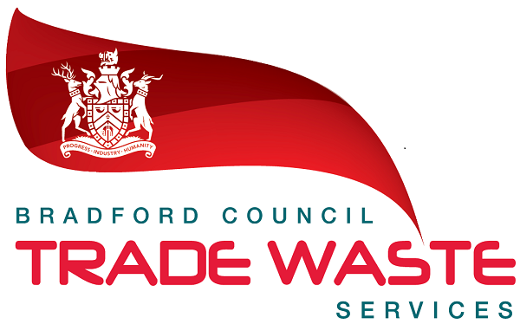
Company logo
or name here
Instruction to your
bank or building society
to pay by Direct Debit
Please fill in the whole form and send it to: Bradford Council Trade Waste Service, Harris St Depot, Harris St, Bradford BD1 5HU  Name and full postal address of your bank or building society |  |  |  |  |  |  |  |  |  |  |  |  |  |  |  |  |  |  |  | Service user number
To: The Manager |  |  |  |  |  |  |  |  | Bank/building society |  |  |  |  |  |  |  |  |  |  | 1 | 6 | 7 | 7 | 4 | 7
Address
 |  |  |  |  |  |  |  |  |  |  | Postcode
Name(s) of account holder(s) |  |  |  |  |  |  |  |  |  |  |  |  |  |  |  |  |  |  |  | Instruction to your bank or building society  Please pay Bradford Council Trade Waste Service Direct Debits from the account detailed in this Instruction subject to the safeguards assured by the Direct Debit Guarantee. I understand that this Instruction may remain with Bradford Council Trade Waste Service and, if so, details will be passed electronically to my bank/building society.
Bank/building society account number
 |  |  |  |  |  |  |  |  |  |  |  |  |  |  |  |  |  |  |  | Signature(s)
Branch sort code
Reference
 |  |  |  |  |  |  |  |  |  |  |  |  |  |  |  |  |  |  |  | Date
Banks and building societies may not accept Direct Debit Instructions for some types of account
DDI4
This is not part of the Instruction to your bank or building society and must be detached by Bradford Council Trade Waste Service before submission to the paying bank.


This guarantee should be detached and retained by the payer.

The Direct Debit Guarantee

- This Guarantee is offered by all banks and building societies that accept instructions to pay Direct Debits
- If there are any changes to the amount, date or frequency of your Direct Debit Bradford Council Trade Waste Service will notify you 10 working days in advance of your account being debited or as otherwise agreed. If you request Bradford Council Trade Waste Service to collect a payment, confirmation of the amount and date will be given to you at the time of the request
- If an error is made in the payment of your Direct Debit, by Bradford Council Trade Waste Service or your bank or building society you
are entitled to a full and immediate refund of the amount paid from your bank or building society
  - If you receive a refund you are not entitled to, you must pay it back when Bradford Council Trade Waste Service asks you to
- You can cancel a Direct Debit at any time by simply contacting your bank or building society. Written confirmation may be required.
Please also notify us.

